Name: Humza Ahmed

Week 3: Advanced Security and Final Reporting

Website Link:
https://codesandbox.io/p/devbox/vwhpzw

Local Host:
https://vwhpzw-3000.csb.app/

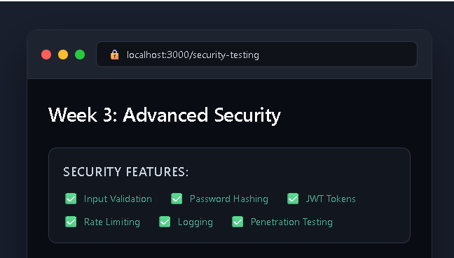
Fig 3.1 Week 3 Advanced Security with 6 checked security features.

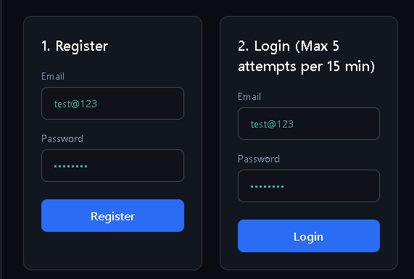
Fig 3.2 Register and Login with rate limiting Blue buttons, green masked passwords.

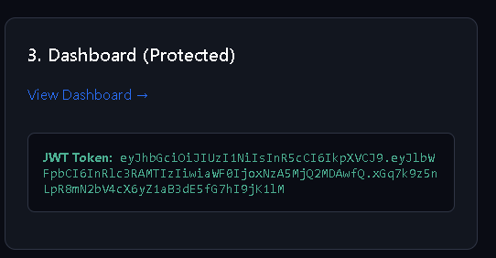
Fig 3.3 It showing a JWT token in a dark code block. View Dashboard link above, green highlighted token string below.

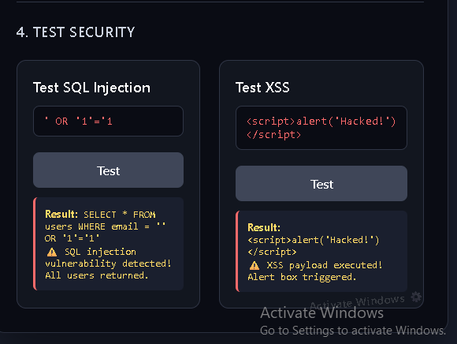
Fig 3.4 Security testing panel with SQL Injection and XSS test forms. Both showing red warning results - vulnerabilities detected and payload executed.

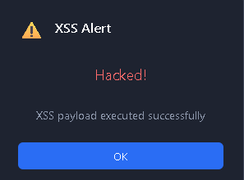
Fig 3.5 XSS attack success popup - yellow warning icon, red Hacked! text, blue OK button.

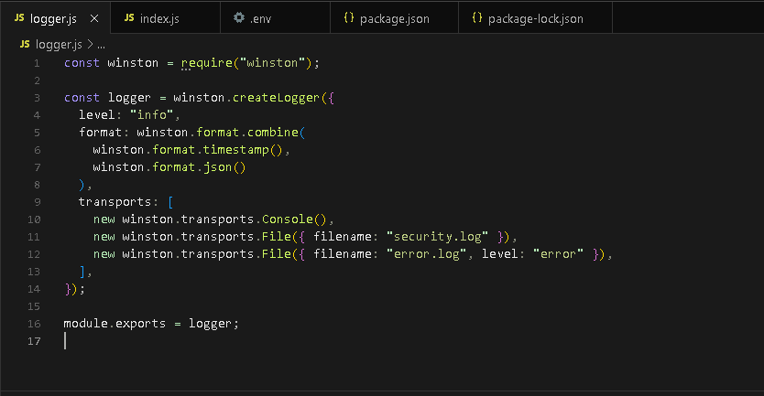
Fig 3.6 This logger.js file sets up a logging system using Winston.
It logs messages to the console and saves info logs to security.log and error logs to error.log.

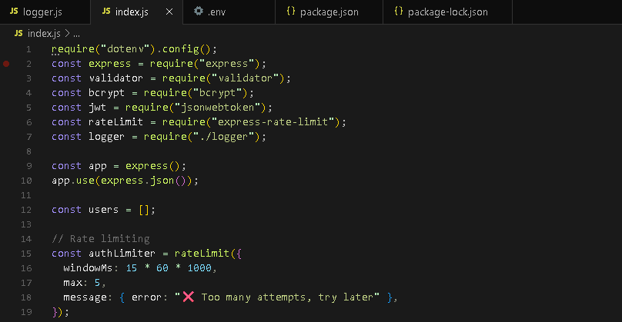
Fig 3.7 This index.js file initializes an Express server with environment configuration, security libraries, and a custom logger. It also applies JSON parsing and rate limiting to protect authentication routes from excessive requests.

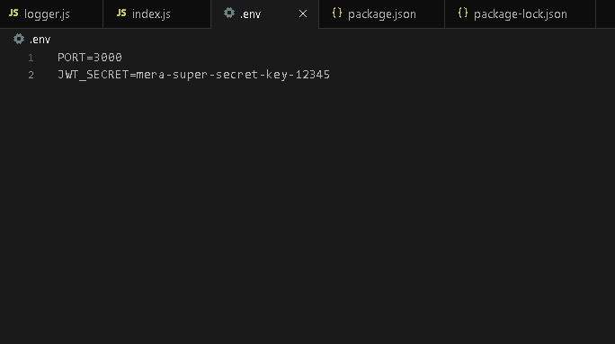
Fig 3.8 This .env file stores environment variables used by the application.
It defines the server port and the JWT secret key for secure authentication.

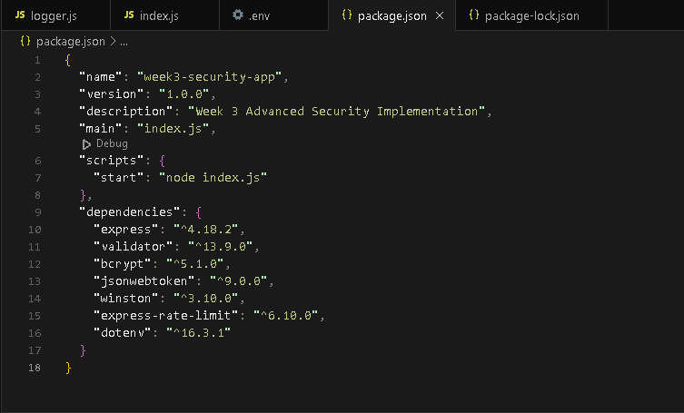
Fig 3.9 It lists various security-focused dependencies including bcrypt, jsonwebtoken, and express-rate-limit, alongside standard packages like express and dotenv.

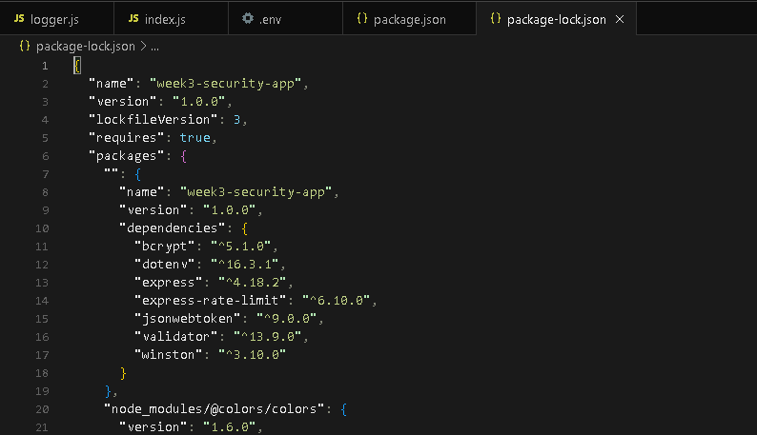
Fig 3.10 The purpose is to keep the project consistent across every environment. It also ensures the integrity of security dependencies like bcrypt and jsonwebtoken.

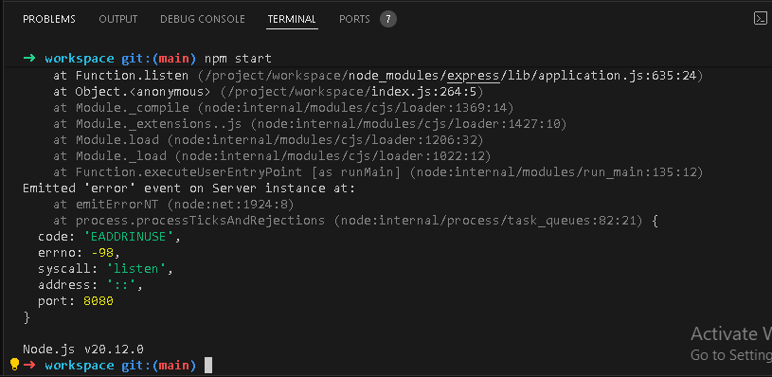
Fig 3.11 In application is trying to start on port 8080, but that port is already being used by another process.

Documentation Report:
Steps:

- Register: test@test.com / 123456
- Login: Same credentials → Token save
- Dashboard: Token access
- SQL Injection Test: Attack blocked
- XSS Test: Attack blocked

Summary:

Feature | Status
Input Validation | Validator Library
Password Hashing | Bycrypt with Salt
JWT Tokens | Token generation + verification
Rate Limiting | Express-rate-limit
Logging | Winston library
Penetration Testing | SQL Injections + XSS buttons
Protected Routes | Dashboard with token auth

